**Measuring success in talent management**

The Tableau HR Scorecard is a framework designed to measure and evaluate the success of talent management strategies within an organization. It provides a way for HR professionals and business leaders to track and analyze key performance indicators (KPIs) related to workforce planning, recruitment, retention, and development. The HR Scorecard consists of four main perspectives:

**1. Financial Perspective**: This perspective focuses on the financial impact of HR initiatives, such as the cost of recruitment, training and development, compensation and benefits, and turnover.

**2. Customer Perspective**: This perspective measures the satisfaction of internal and external customers of HR services, including employees, managers, and job candidates. It includes KPIs such as employee engagement, manager satisfaction with HR support, and candidate experience.

**3. Internal Process Perspective**: This perspective assesses the effectiveness and efficiency of HR processes, such as recruiting, onboarding, performance management, and employee development. It includes KPIs such as time to fill vacancies, time to productivity for new hires, and training hours per employee.

**4. Learning and Growth Perspective**: This perspective evaluates the organization's investment in employee development and its ability to innovate and adapt to changing business needs. It includes KPIs such as employee skills and competencies, employee retention, and the percentage of employees who receive regular training and development.

**Milestone 1: Define Problem / Problem Understanding**

To measure success effectively, it's crucial to identify and track relevant Key Performance Indicators (KPIs) for each aspect of talent management. KPIs could include metrics such as employee turnover rates, time-to-fill positions, training completion rates, and employee satisfaction scores.

**Business requirements :**

The business requirement of The Tableau HR Scorecard: Measuring Success in Talent Management is to provide a comprehensive and effective framework for measuring and evaluating the success of talent management strategies within an organization. The primary goal is to enable HR professionals and business leaders to track and analyze key performance indicators (KPIs) related to workforce planning, recruitment, retention, and development. We can do so by creating interactive dashboards and reports, making data-driven decisions and creating forecasting models for future performance. The ultimate goal is to gain insights and improve performance through data visualization techniques.

**Literature Survey:**

A literature survey is a method of researching existing literature and studies related to a specific topic. In the context of Measuring Success in Talent Management, a literature survey would involve reviewing studies and articles that have been published on the topic of vehicle collisions. The literature survey would include sources such as academic journals, industry reports, and online articles. It would aim to identify key performance indicators (KPIs) and metrics that are commonly used to measure vehicle collisions.The literature survey would also explore any existing research on The Tableau HR Scorecard: Measuring Success in Talent Management specifically, and would aim to identify any unique challenges.

**Social Model/Impact:**

1. Improved employee engagement: The HR Scorecard can help organizations measure and improve employee engagement by providing insights into employee satisfaction, retention rates, and other key metrics. This, in turn, can lead to a more engaged and motivated workforce, which can have a positive impact on productivity and overall business performance.

2. Enhanced diversity and inclusion: The HR Scorecard can also help organizations improve their diversity and inclusion efforts by tracking metrics such as the diversity of their workforce, the representation of different groups in leadership positions, and the effectiveness of diversity and inclusion training programs. By identifying areas where they need to improve and taking action to address them, organizations can create a more inclusive work environment that values diversity and promotes equal opportunities.

**Business Model/Impact**

1. Improved HR performance: By tracking and analyzing key HR metrics, The Tableau HR Scorecard can help organizations identify areas where they need to improve and take proactive steps to address them. This, in turn, can lead to improved HR performance, including increased employee engagement, improved retention rates, and enhanced diversity and inclusion efforts.

2. Enhanced decision-making: The Tableau HR Scorecard can provide HR professionals and business leaders with valuable insights into HR performance, which can help them make informed decisions and take proactive steps to improve business performance. This can include identifying areas where they need to invest in training and development programs, improving recruitment and retention strategies, and optimizing workforce planning and management.

3. Better alignment with business goals: The Tableau HR Scorecard can also help organizations ensure that their HR strategies are aligned with their overall business goals. By tracking key HR metrics and aligning HR initiatives with business objectives, organizations can ensure that their HR strategies are driving business growth and contributing to overall success.

**Data Preparation**

Prepare the Data for Visualization Preparing the data for visualization involves cleaning the data to remove irrelevant or missing data, transforming the data into a format that can be easily visualized, exploring the data to identify patterns and trends, filtering the data to focus on specific subsets of data, preparing the data for visualization software, and ensuring the data is accurate and complete. This process helps to make the data easily understandable and ready for creating visualizations to gain insights into the performance and efficiency.

**Department wise Attrition**

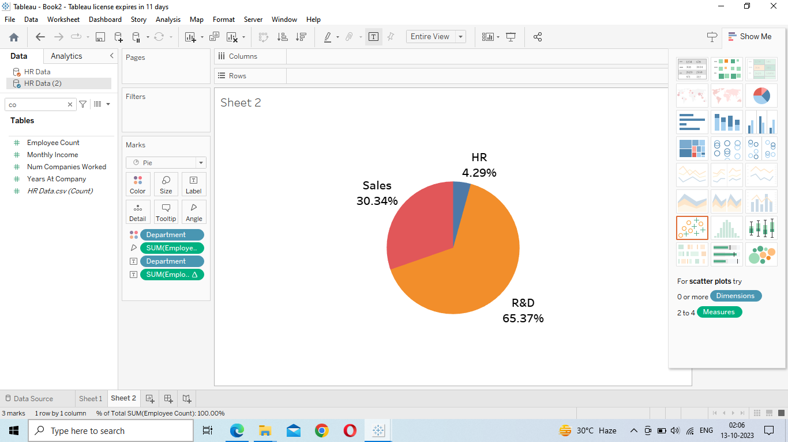

**No. of employees by Age Group**:

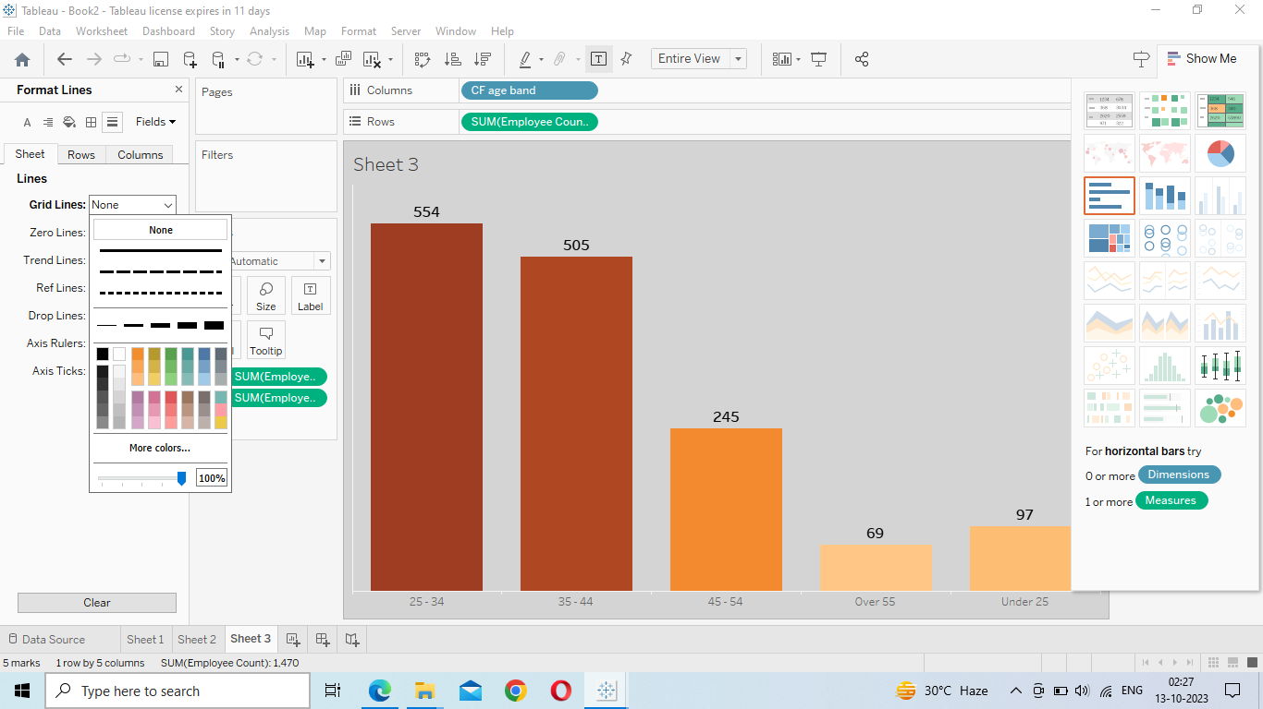

**Job Satisfaction Rating:**

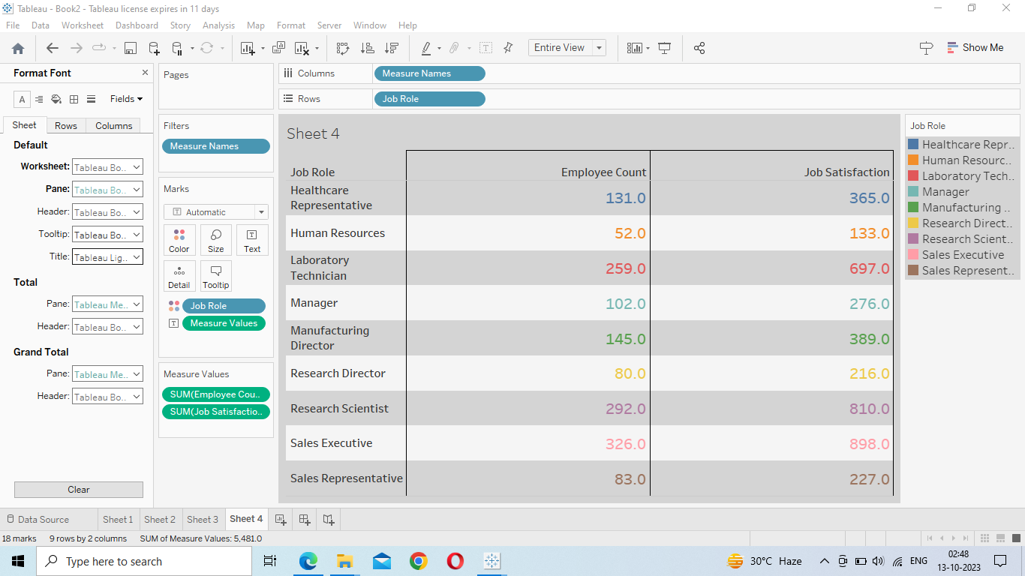

**Education Field wise Attrition:**

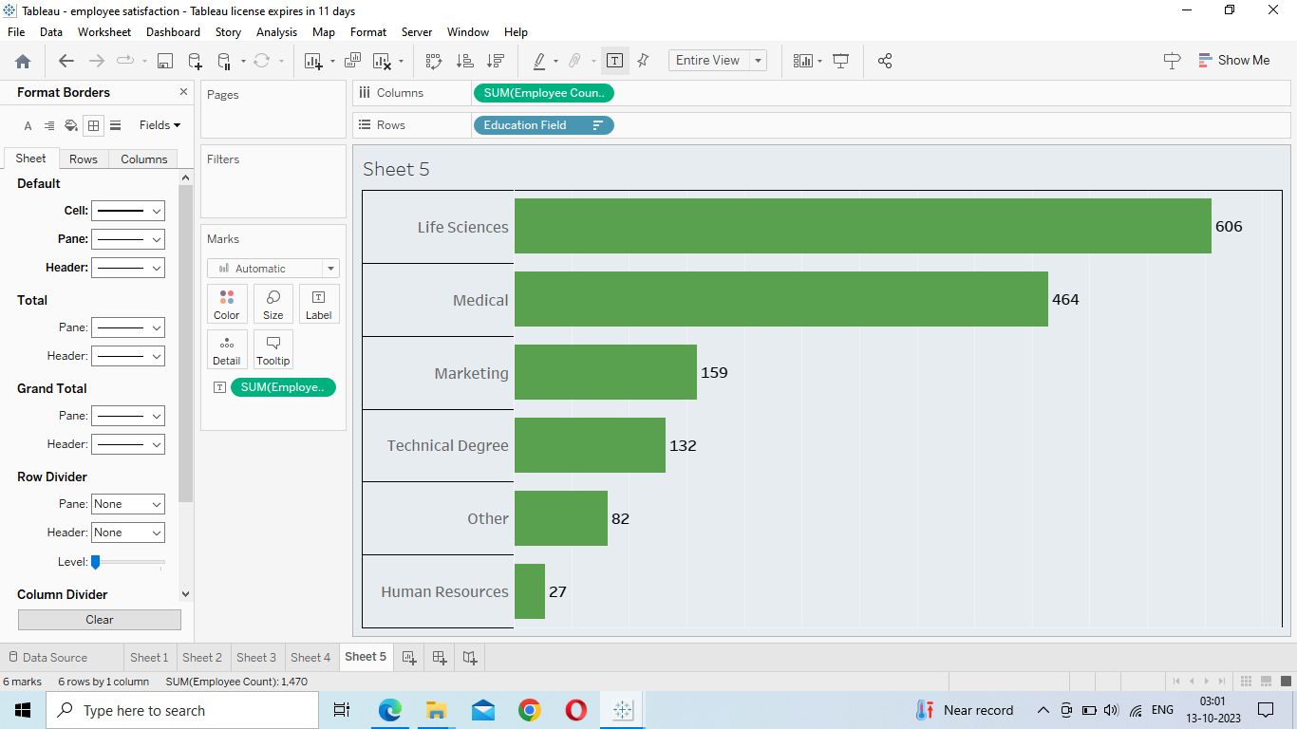

**Dashboard:**

A dashboard is a graphical user interface (GUI) that displays information and data in an organized, easy-to-read format. Dashboards are often used to provide real time monitoring and analysis of data, and are typically designed for a specific purpose or use case. Dashboards can be used in a variety of settings, such as business, finance, manufacturing, healthcare, and many other industries. They can be used to track key performance indicators (KPIs), monitor performance metrics, and display data in the form of charts, graphs, and tables.

**Responsive and Design of Dashboard:**

The responsiveness and design of a dashboard for The Tableau HR Scorecard: Measuring Success in Talent Management is crucial to ensure that the information is easily understandable and actionable. Key considerations for designing a responsive and effective dashboard include user-centered design, clear and concise information, interactivity, data-driven approach, accessibility, customization, and security. The goal is to create a dashboard that is user friendly, interactive, and data-driven, providing actionable insights to analyze vehicle collisions.

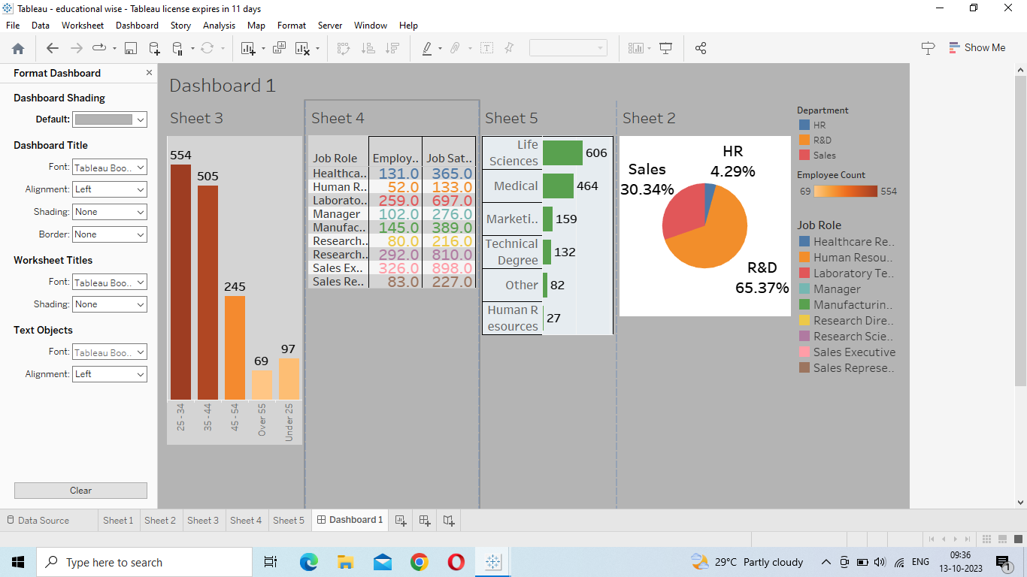

**Story:**

A data story is a way of presenting data and analysis in a narrative format, with the goal of making the information more engaging and easier to understand. A data story typically includes a clear introduction that sets the stage and explains the context for the data, a body that presents the data and analysis in a logical and systematic way, and a conclusion that summarizes the key findings and highlights their implications. Data stories can be told using a variety of mediums, such as reports, presentations, interactive visualizations, and videos.

